***C Programming***

**Assignment 1**

1. Write a c program to evaluate expressions.

Program

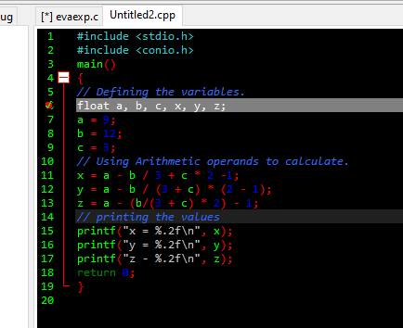

Output.

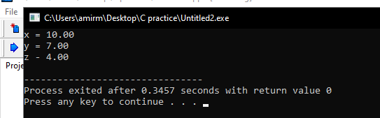

2. Write a c program using getchar() and putchar() for character input and output.

Program

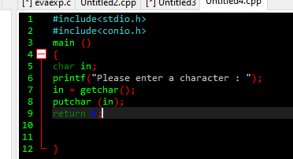

Output

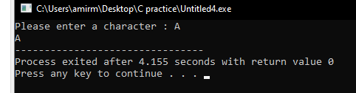

3. Write a c program using gets() and puts() for string input and output?

Program

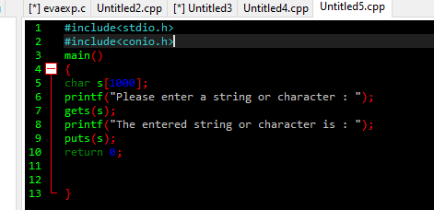

Output.

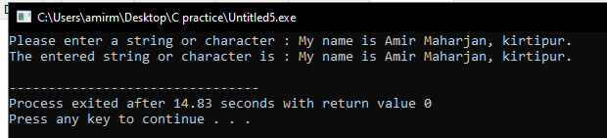

4. Write a c program to scan one character and two strings: one of 10-character length and another of 20-character length and print them.

Program.

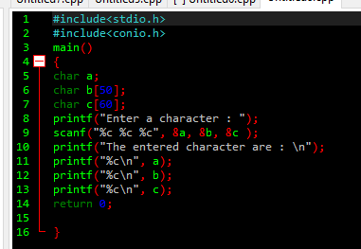

Output

